40.7: The first excited state or 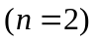 wave function is 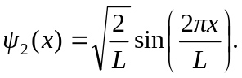
So 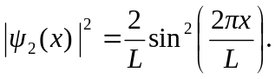
a) If the probability amplitude is zero, then 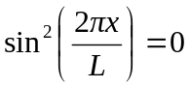
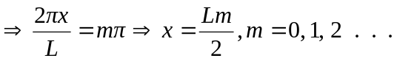
So probability is zero for 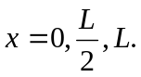
b) The probability is largest if 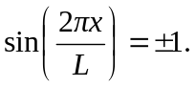
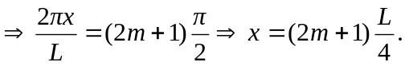
So probability is largest for 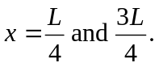
c) These answers are consistent with the zeros and maxima of Fig. 40.5.

